Program-1:// Compute the area of a circle.

class Area {

public static void main(String args[]) {

double pi, r, a;

r = 10.8; // radius of circle

pi = 3.1416; // pi, approximately

a = pi \* r \* r; // compute area

System.out.println("Area of circle is " + a);

}

}

Output:

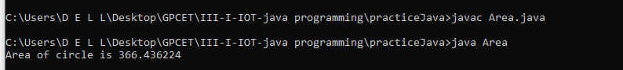

Program-2: // Demonstrate char data type.

class CharDemo {

public static void main(String args[]) {

char ch1, ch2;

ch1 = 88; // code for X

ch2 = 'Y';

System.out.print("ch1 and ch2: ");

System.out.println(ch1 + " " + ch2);

}

}

Output:

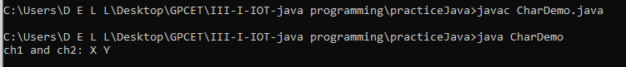

Program-3: // char variables behave like integers.

class CharDemo2 {

public static void main(String args[]) {

char ch1;

ch1 = 'X';

System.out.println("ch1 contains " + ch1);

ch1++; // increment ch1

System.out.println("ch1 is now " + ch1);

}

}

Output:

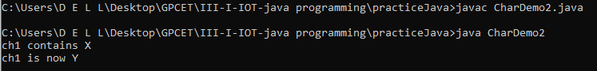

Program-4: // Demonstrate boolean values.

class BoolTest {

public static void main(String args[]) {

boolean b;

b = false;

System.out.println("b is " + b);

b = true;

System.out.println("b is " + b);

// a boolean value can control the if statement

if(b) System.out.println("This is executed.");

b = false;

if(b) System.out.println("This is not executed.");

// outcome of a relational operator is a boolean value

System.out.println("10 > 9 is " + (10 > 9));

}

}

Output:

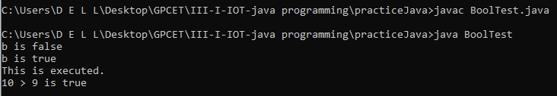

Program-5: // Demonstrate dynamic initialization.

class DynInit {

public static void main(String args[]) {

double a = 3.0, b = 4.0;

// c is dynamically initialized

double c = Math.sqrt(a \* a + b \* b);

System.out.println("Hypotenuse is " + c);

}

}

Output:

